UML of LAB 4

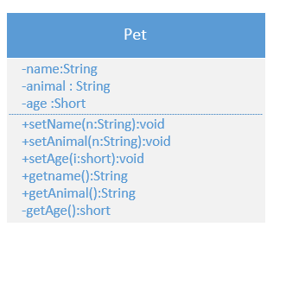

//Parth Barot  
//Lab 4  
//6/18/2015  
  
import java.util.\*;  
  
public class Pet{  
  
 public static void main(String [] args){  
 //Data Dictionary  
   
 Pet1 myPet = new Pet1();  
 int buffer =0; //decalring buffer as integer.  
 String buffer1= "";  
 String menu = "(-1) quit, (1) setName , (2)setAnimal, (3)setAge";  
   
 menu += "\n (4) getName , (5) getAnimal (6) gerAge : ";   
 Scanner kbd = new Scanner(System.in);// Creating new scanner object into main meathod.  
   
 do{  
 System.out.print(menu);  
 buffer =kbd.nextInt();  
 if(buffer == -1)break;  
   
 if (buffer ==1) {  
   
 System.out.print("Enter the pet name : ");  
 myPet.setName(kbd.next());  
 }  
   
 if(buffer == 2){  
 System.out.println("Enter set Animal type : ");  
 myPet.setAnimal(kbd.next());  
   
 }  
 if (buffer == 3) {  
 System.out.print("Enter the pet age : ");  
 myPet.setAge(kbd.nextShort());  
   
 }  
 if (buffer == 4){  
 System.out.println(myPet.getName());  
 }  
   
 if(buffer == 5) {  
 System.out.println(myPet.getAnimal());  
 }   
 if (buffer == 6) {  
 System.out.println(myPet.getAge());  
   
 }  
   
   
   
 }while(buffer != -1);  
 }  
}  
class Pet1{ //Creating new pet1 class to set name , animal, age  
   
 private String name = "";  
 private String animal = "";  
 private short age = 0;  
  
  
 public void setName(String n){  
 name = n;  
   
 }  
 public void setAnimal(String n){  
 animal = n;  
   
 }  
 public void setAge(short i){  
 age = i;  
 }  
   
 public String getName(){  
 return name;  
 }   
   
   
 public String getAnimal(){  
 return animal;  
 }  
   
 public short getAge(){  
 return age;  
 }  
   
   
   
}

OUTPUT

